NoSQL : MongoDB Document Database

Creation of ad-hoc query:

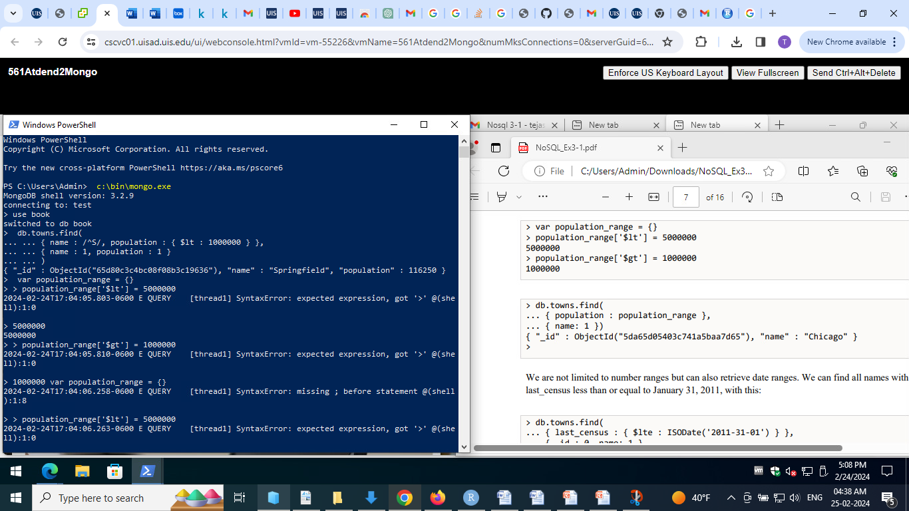

Description:

Queried to get the result with names of cities that begin with capital ‘S’ and with the population less than 1,000,000 using the placeholder and the regular expression.

Retrieval of objects using number ranges:

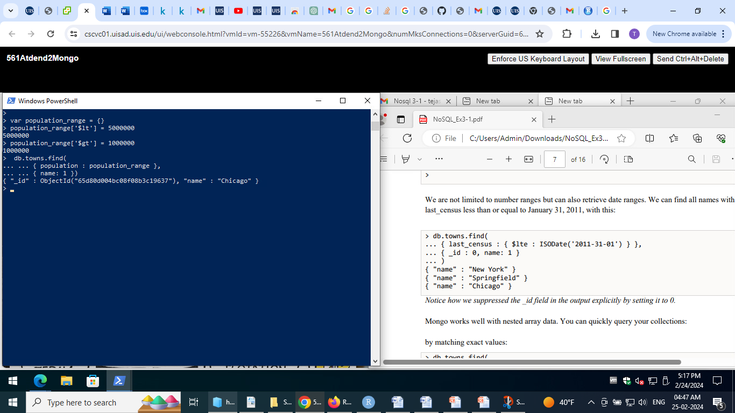

Retrieval of objects using date range:

Finding all names with a last_census less than or equal to January 31, 2011 as follows:

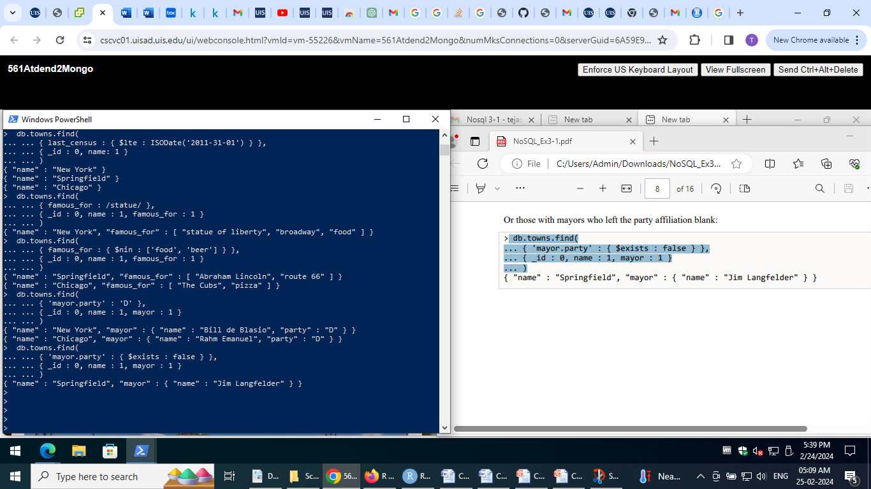

Getting the object that

1. matches the exact values in it as queried:

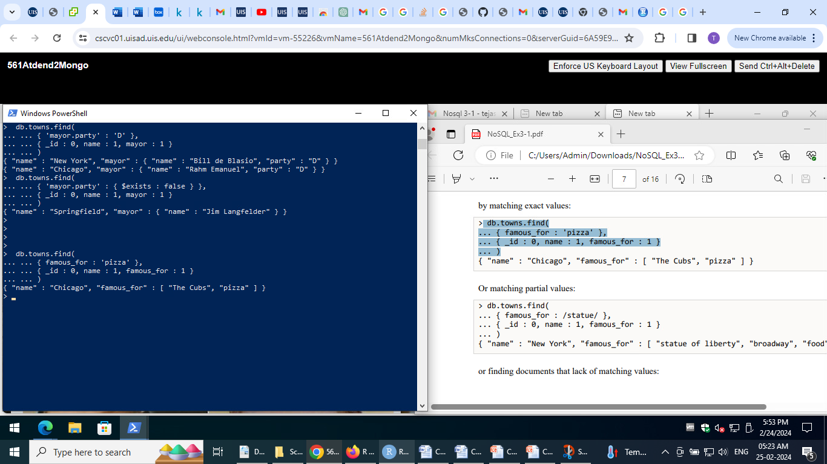

1. Matches the partial values:



c) finding documents that lacks matching values:



Here ‘nin‘ is used to find the documents that don’t match the given values.

Query a sub document:





Here, the last query retrieves the subdocument that illustrates the non-affiliation with a field ina document.

Continued in the next page

Section 2.4: Query using directives

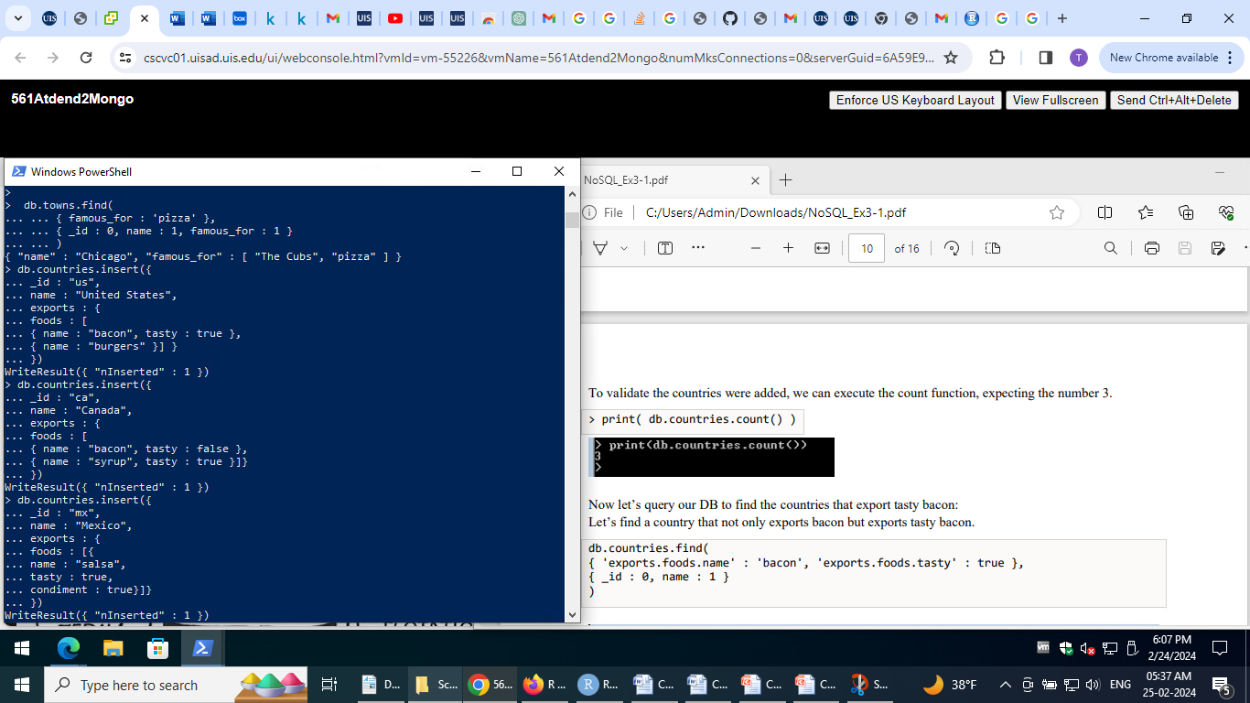

Print the count of documents:

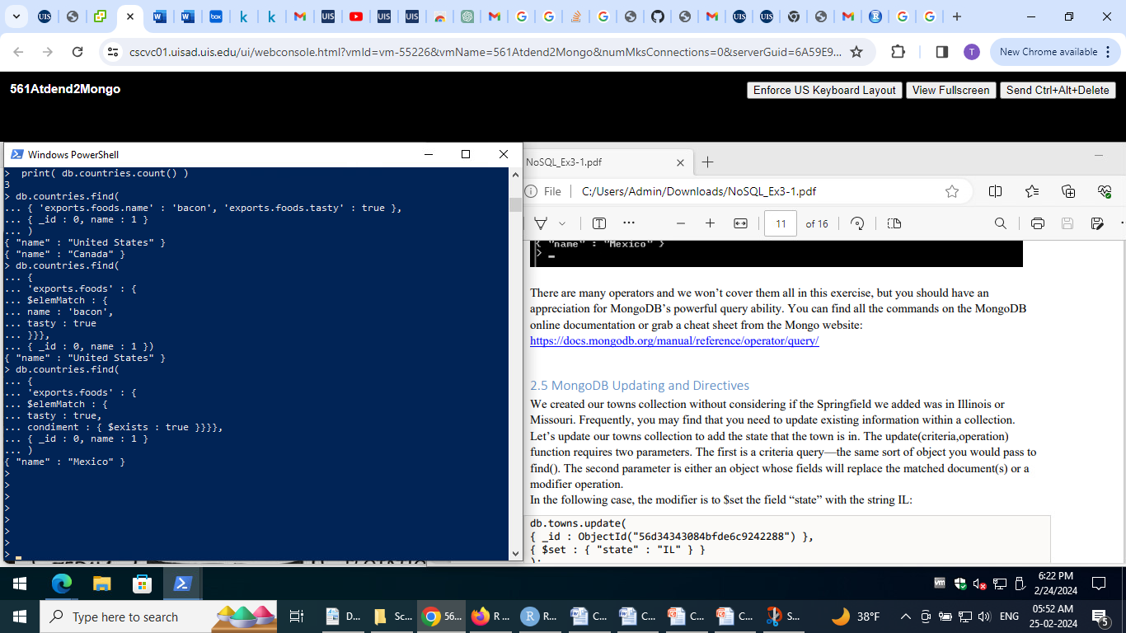

Query using advance operators:

Example: $elemMatch operator - specifies that if a document (or nested document) matches all criteria



Update directive

It specifies that if a document (or nested document) matches all of our criteria

Illustration of the modifier is to $set the field “state” with the string IL:

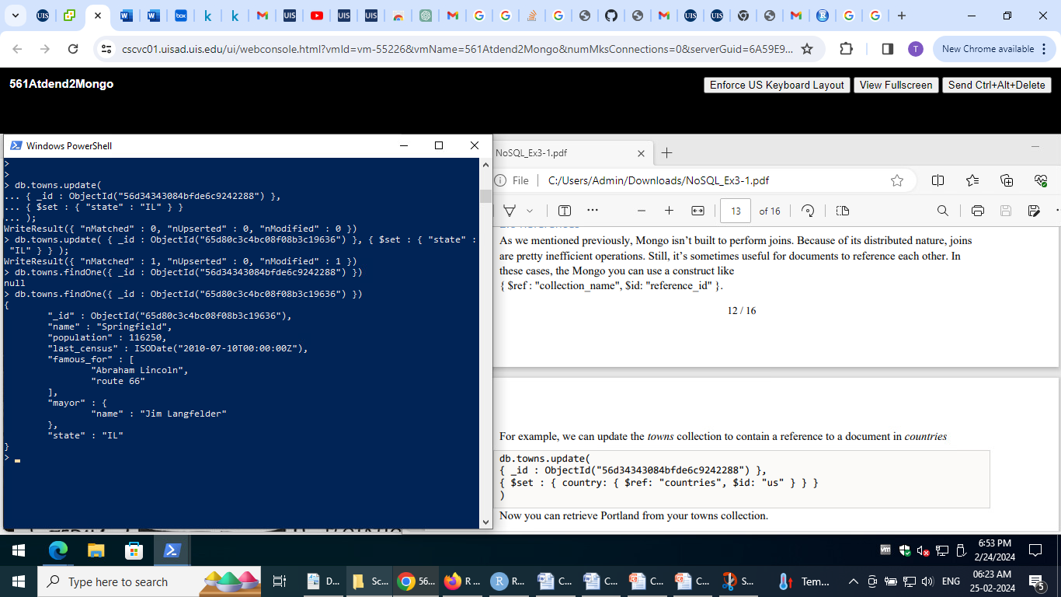Validation of set modifier:



References

In these cases, the Mongo you can use a construct like { $ref : "collection_name", $id: "reference_id" }.

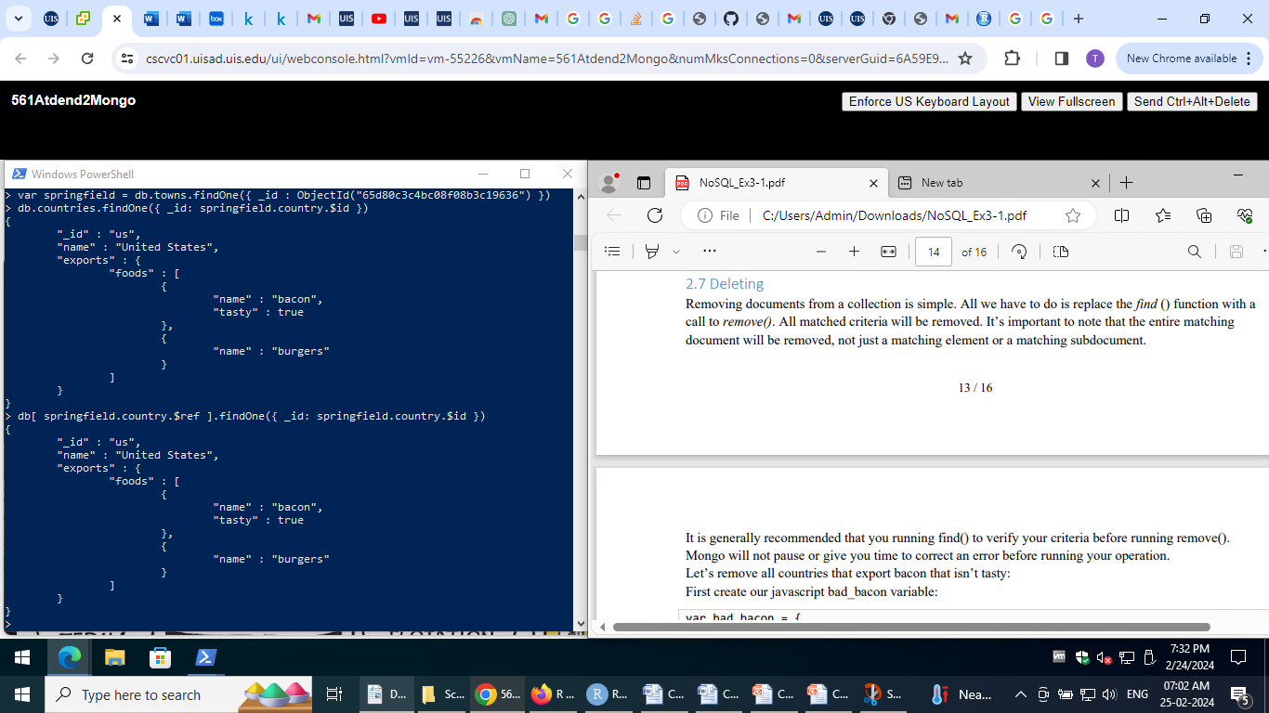Here retrieved the town’s country from the countries collection using the stored $id

Deletion

This can be done using remove()

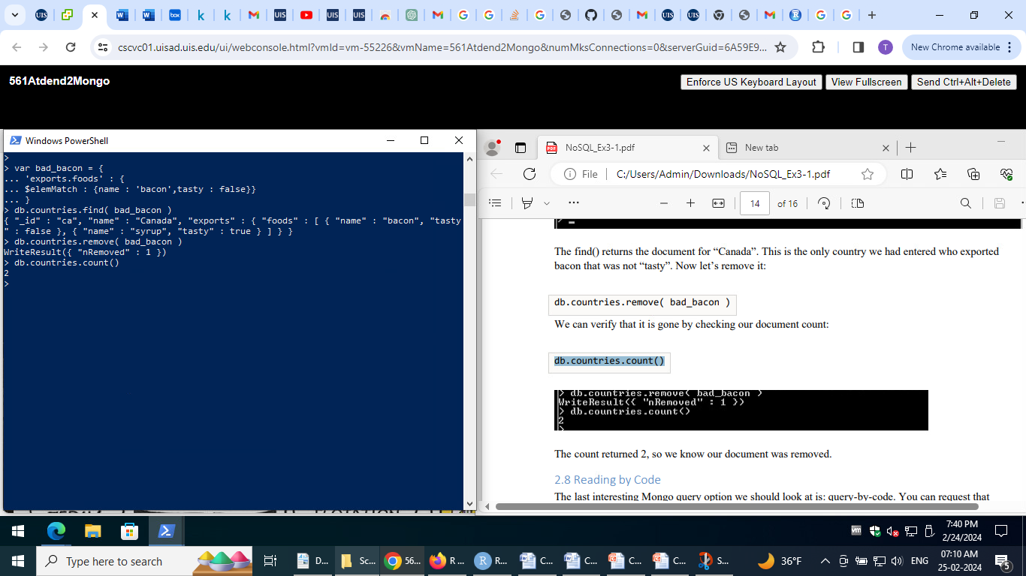

Here, the country that exported the bacon that’s not tasty is deleted and it’s verified using the count()

Reading by Code

MongoDB can run a decision function across your documents. These queries run quite slowly, you can’t index them, and Mongo can’t optimize them.

Here is a query for a city with a population between 6,000 and 600,000 people.

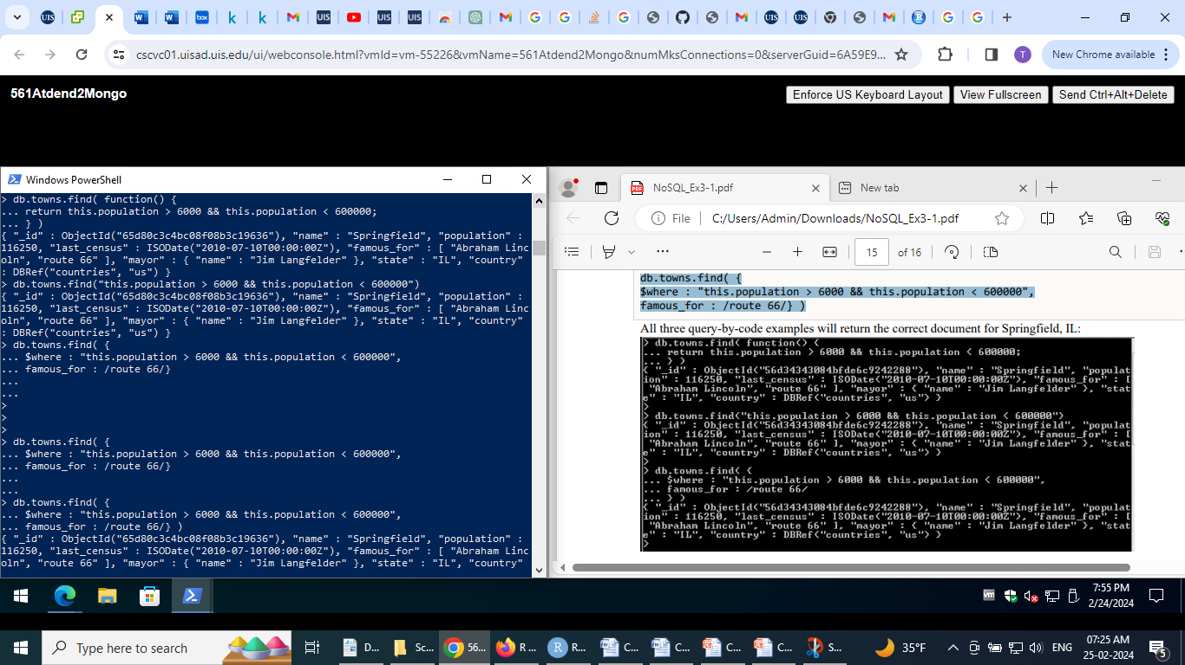

It also illustrates that Mongo even has a shortcut for simple decision functions, use the object instance reference, this.

Custom code with other criteria using the $where clause which also allows to filter:

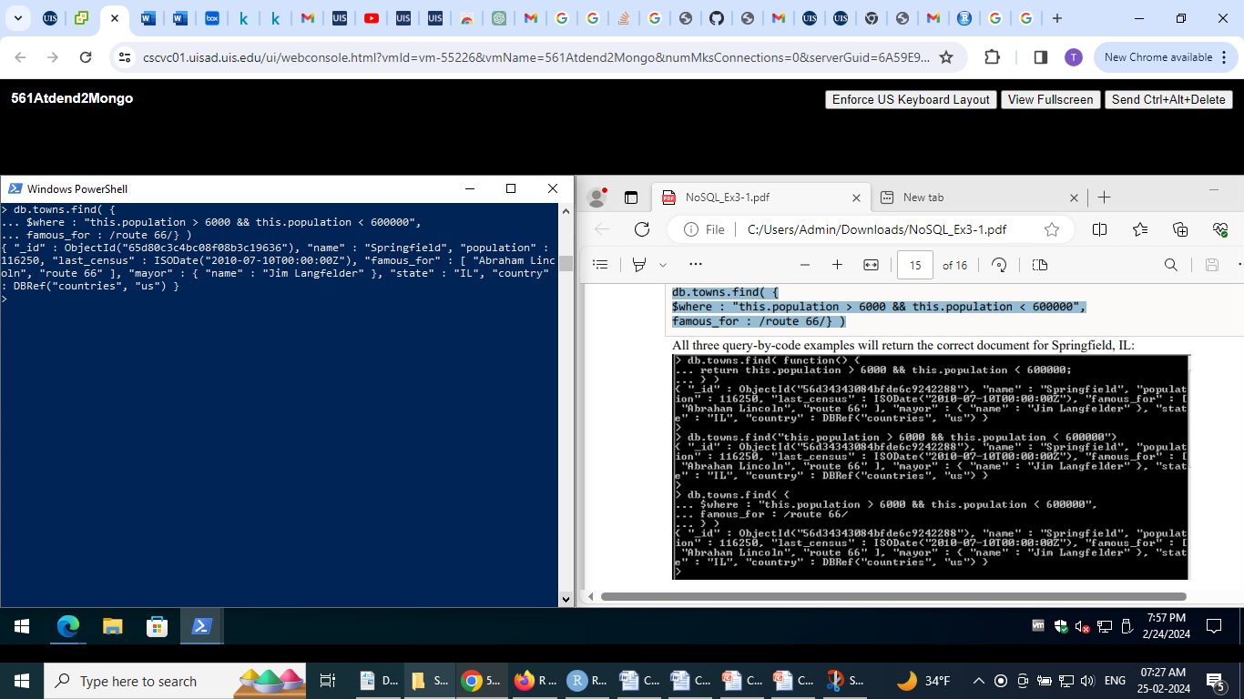

Here the query also filtered for towns famous for “route 66”.

------------------------------------------------------------------------------------------------------------------------------------------

Create the following document database by crawling contents from the Dept. of Computer Science @ UIS A3.1

Create a new database. • Name: “CSUIS”: A3.2 (10pts) Create three users

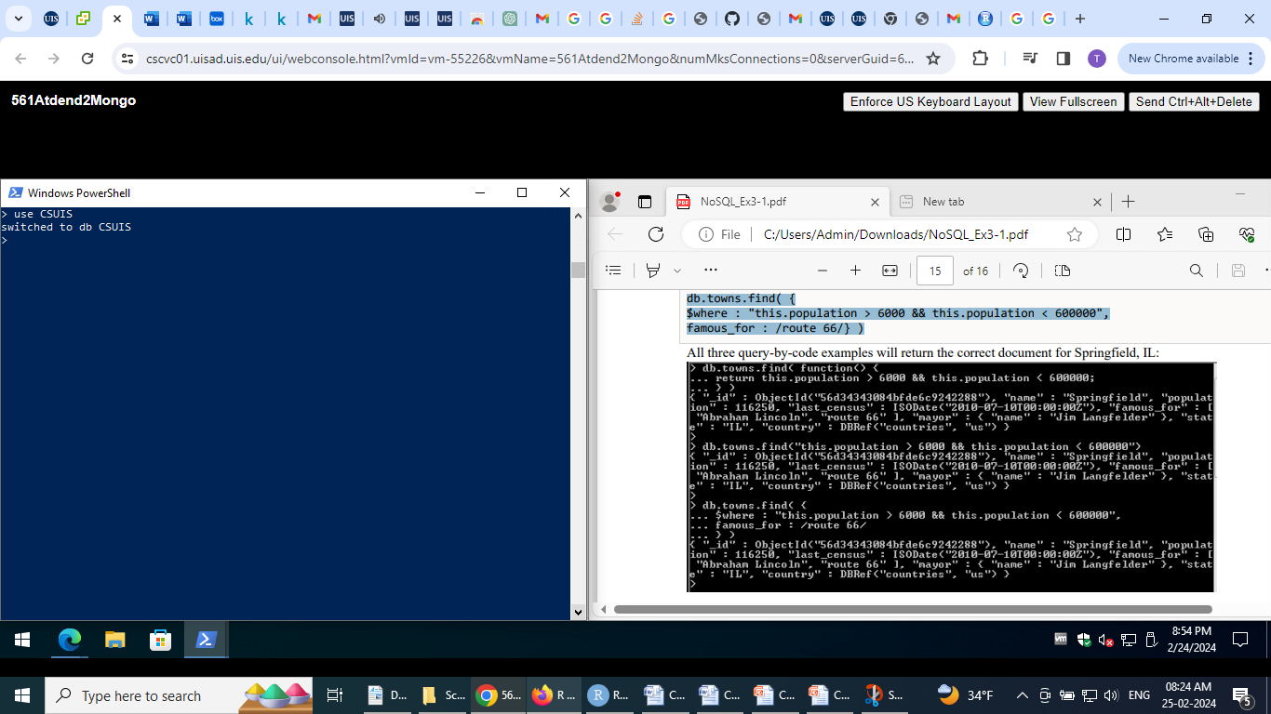

• Create three users with _id = "9bb26043708926e438db6c9a", "9bb26043708926e438db6c9b", "9bb26043708926e438db6c9c".

• The users’ collection should contain the fields name and email.

• For the field _id, use ObjectId instead of String o Ex: "_id" :ObjectId("9bb26043708926e438db6c9a")

User1:

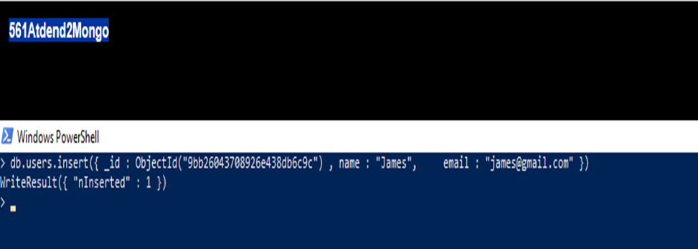

User2:

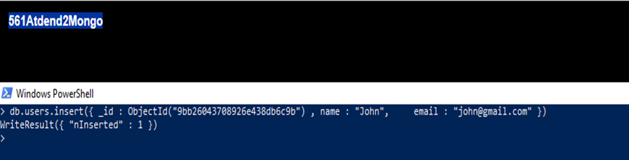

User3:

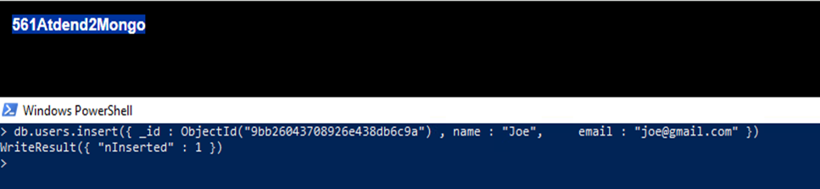

• List the contents of the users’ collection in pretty form. 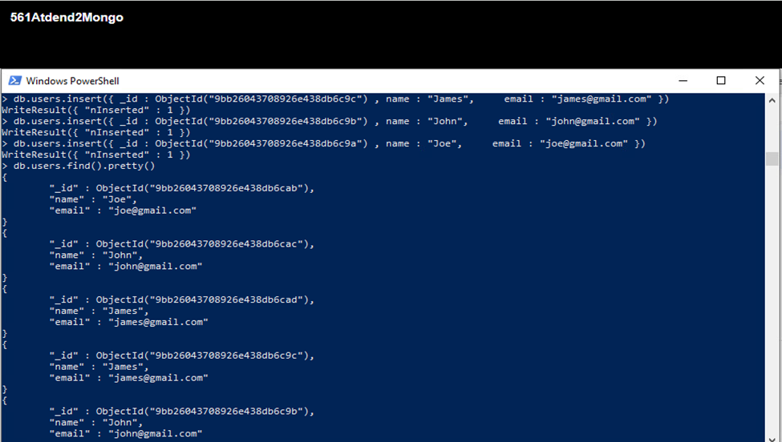

• Search for user 9bb26043708926e438db6c9a A3.3 (13pts)

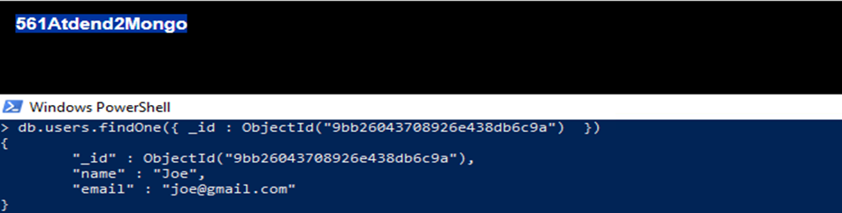

Create three blogs

• Create three blogs with 6 fields: title, body, slug, author, comments (array with objects containing user_id, comment, approved, created_at), and category (array with objects containing name)

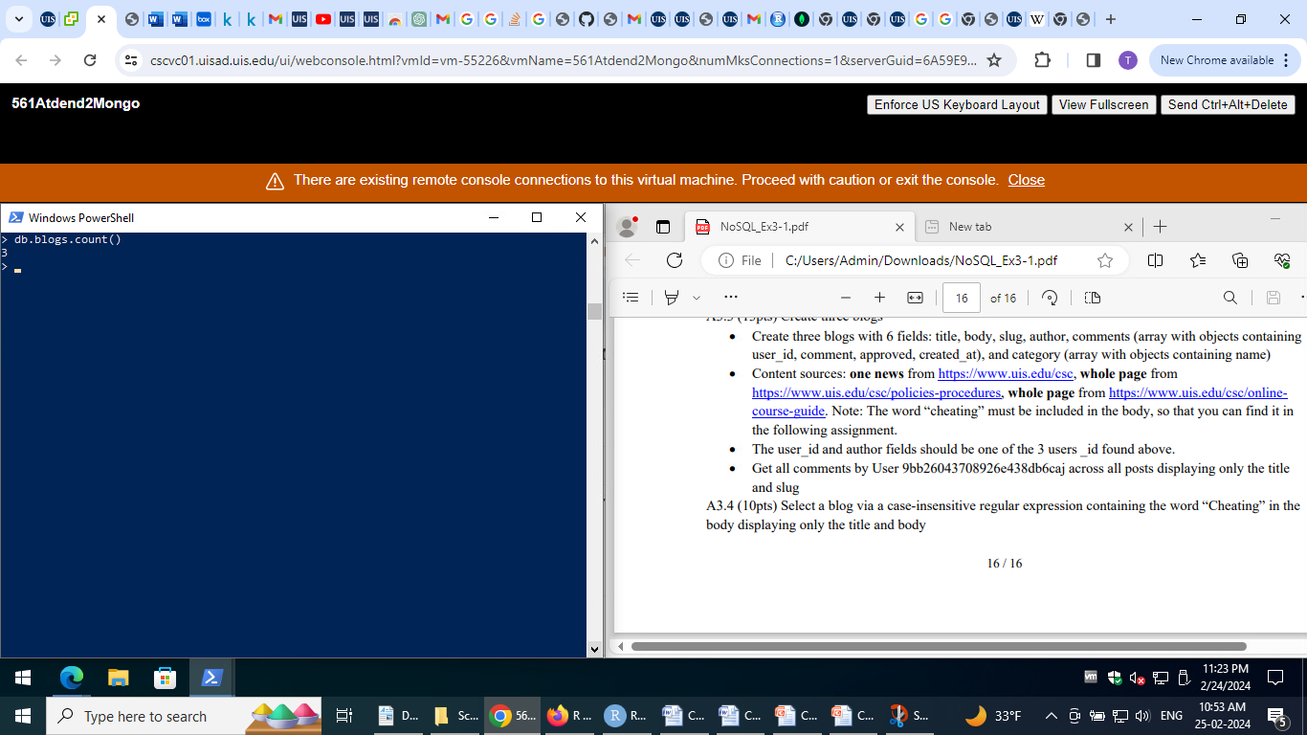• Content sources: one news from https://www.uis.edu/csc, whole page from https://www.uis.edu/csc/policies-procedures, whole page from https://www.uis.edu/csc/onlinecourse-guide. Note: The word “cheating” must be included in the body, so that you can find it in the following assignment.

• The user_id and author fields should be one of the 3 users _id found above.

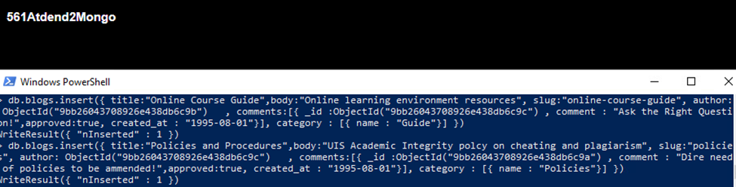

• Get all comments by User 9bb26043708926e438db6c9c across all posts displaying only the title and slug

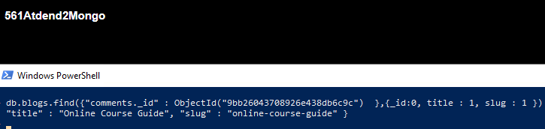

Select a blog via a case-insensitive regular expression containing the word “Cheating” in the body displaying only the title and body

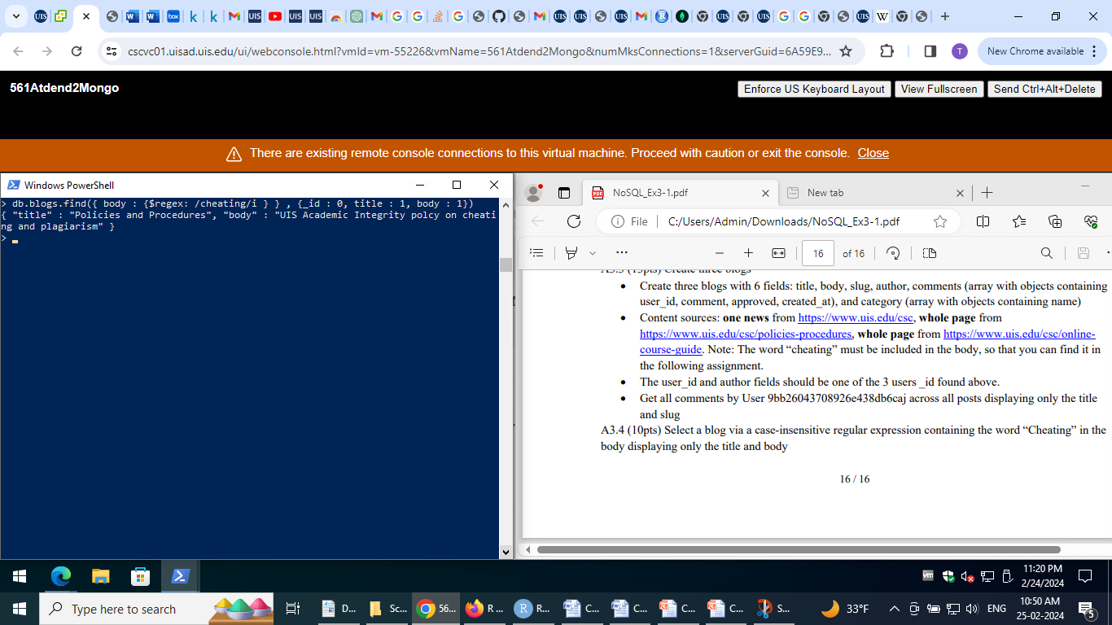

====================================THE END=========================================